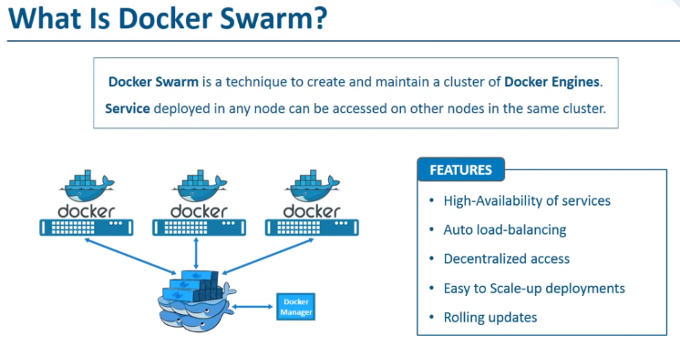
Lets create the above diagram and see all this features ‘practically’:

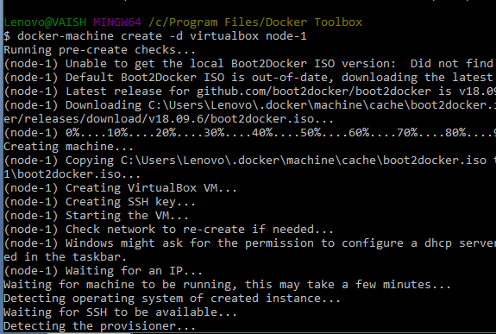
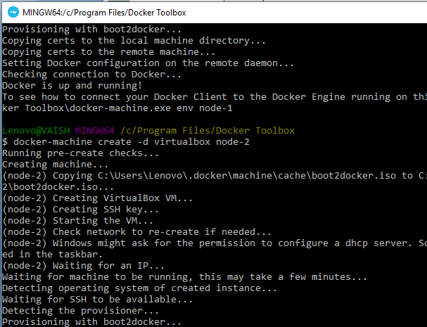

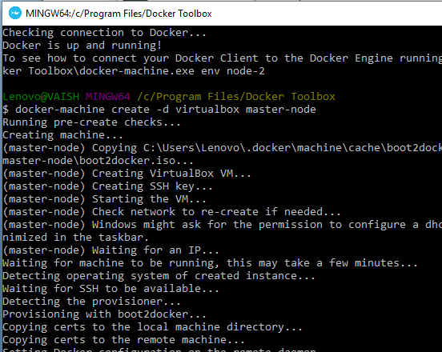
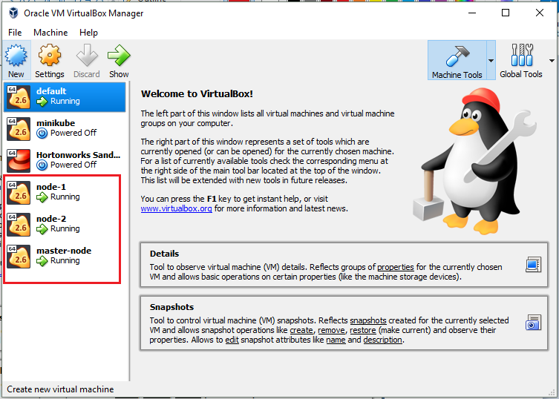
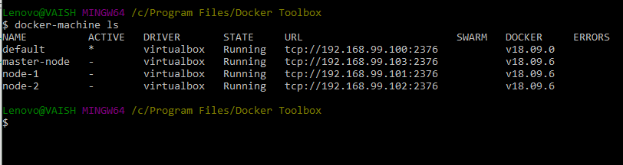
We can see all the nodes here. Right now these are simple nodes which are not connected with each other. No Master-Slave hierarchy is yet being followed.
The naming convention of master-node, node-1 and node-2 has been made so that respective responsibilities will be given to them in future.
Let’s switch to a node (names ad master-node)
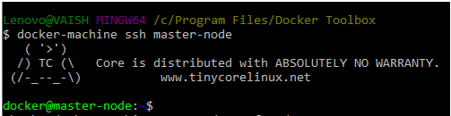
You can see the terminal prompt changed to docker@master-node. Here we will initialize docker swarm:
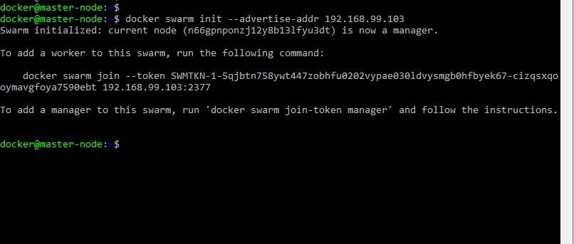
NOTE: Here, we used Master Node’s IP. And after initialization, we can read that this node (which was named as master-node) has actually become master. The intension behind nomenclature is fulfilled.
Now, it’s time to add the nodes in the swarm: Launch a new Docker Terminal and issue the below command to switch into a node (This time worker node):
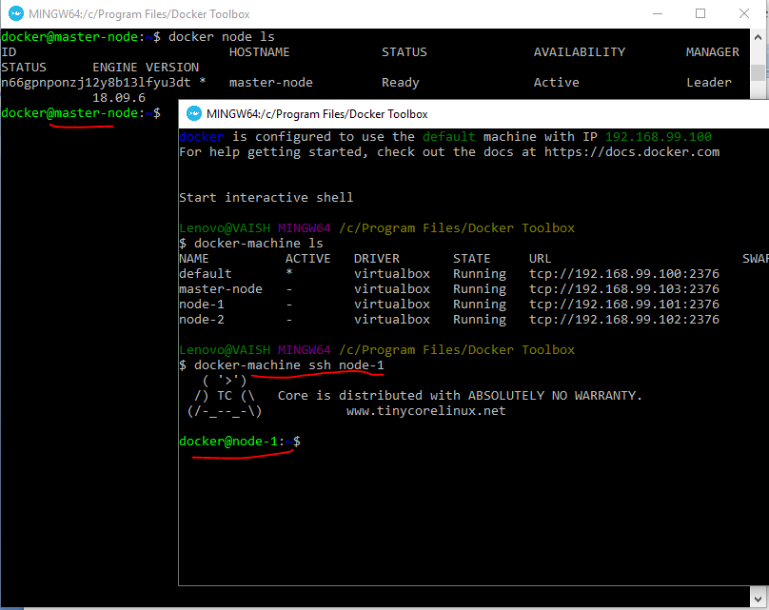
If you noticed in the previous figure, when we initialized the docker swarm from a node (named master) to make it the actual master, in the terminal the command with token was generated. Now to add node-1 in the swarm we will make use of the same.
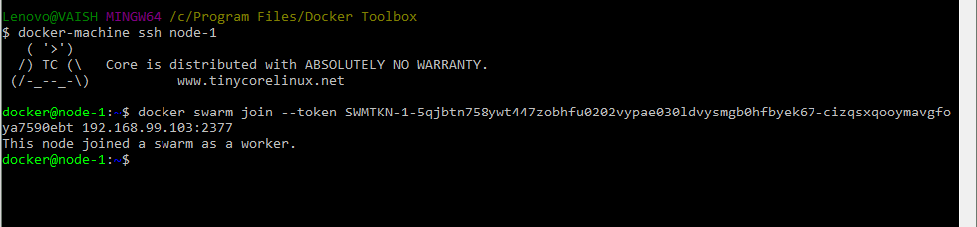

Similarly to add node-2 in the swarm, launch docker Terminal, ssh into node-1, issue the join command to register itself as a worker node in the swarm.

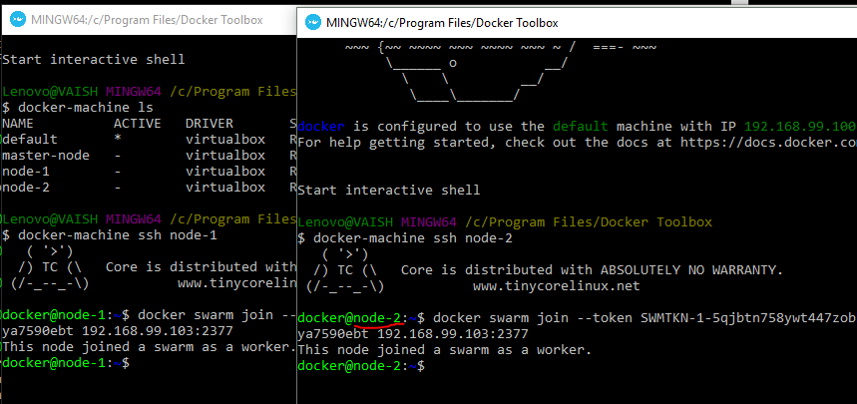

To check the Master –Slave Architecture:
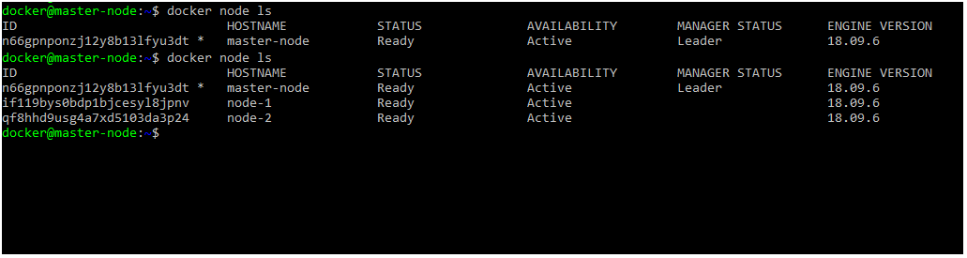
To Test:
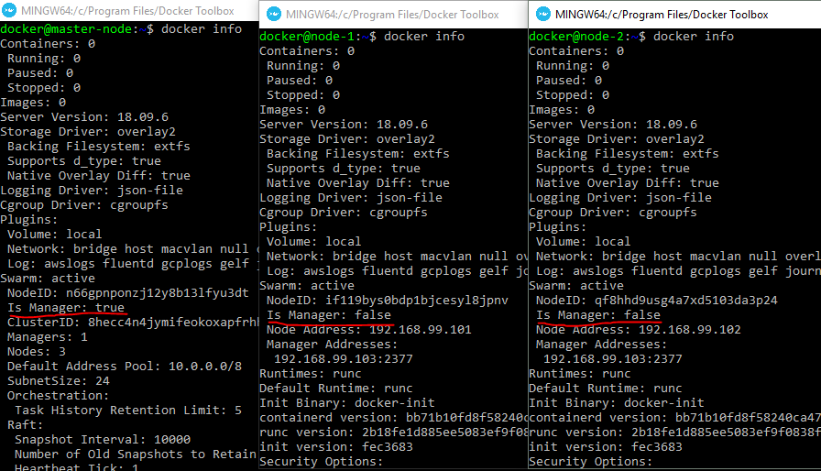
Now, we have our swarm up and running!!
FYI: docker-machine ls, lists IPs of all nodes (master and slaves):
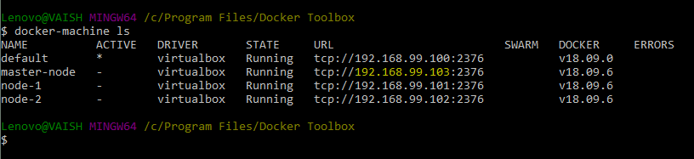

Time for Application Deployment:
We have deployed the image on master using the below command:
MASTER-NODE IP: PORT/hello – success
NODE1 IP:PORT/hello – failure
NODE2:PORT/hello –failure

Similarly, when we deploy the on node-1:
MASTER-NODE IP:PORT/hello – failure
NODE1 IP:PORT/hello – success
NODE2:PORT/hello –failure
Therefore deployment is specific to the machine/node (IP). Now, let’s understand Services:

On execution below command on MASTER node:
We see master and slaves responding as:

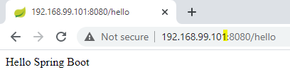
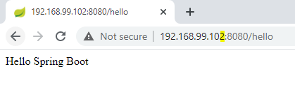
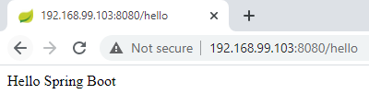
We cannot launch a service from a node. It is meant to launch from ONLY MASTER. If we try to execute a service from a node, we get the below response:
Error response from daemon: This node is not a swarm manager. Worker nodes can't be used to view or modify cluster state. Please run this command on a manager node or promote the current node to a manager.

To test the service status:
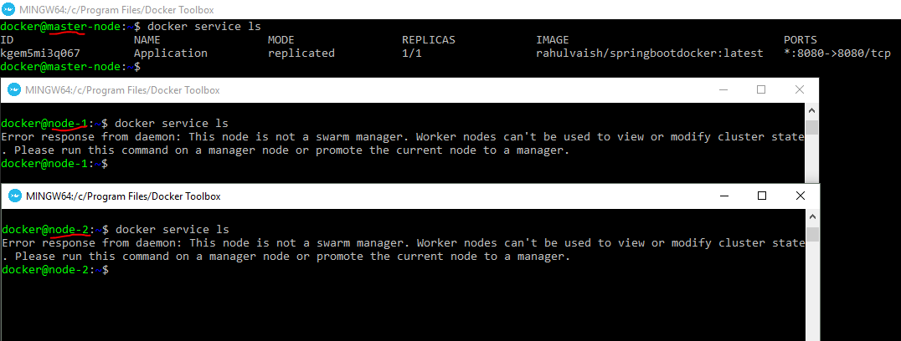
Executing , docker service ls and docker service ps , we come to know that they are supposed to execute on master node and not on worker nodes!

On executing docker ps, on master , node-1 and node-2, it was determined that the process is listed under Node-2.
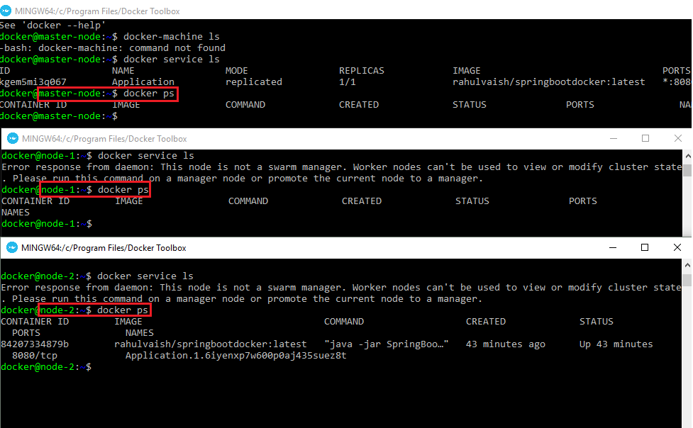
Now let’s see how to create number of instances for each node. To do the same, first pull down the running service, and post that re-create the new service with global mode.
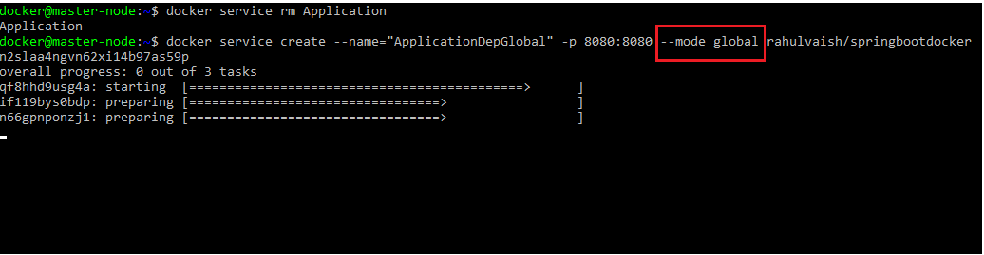
Now on docker ps on all three nodes
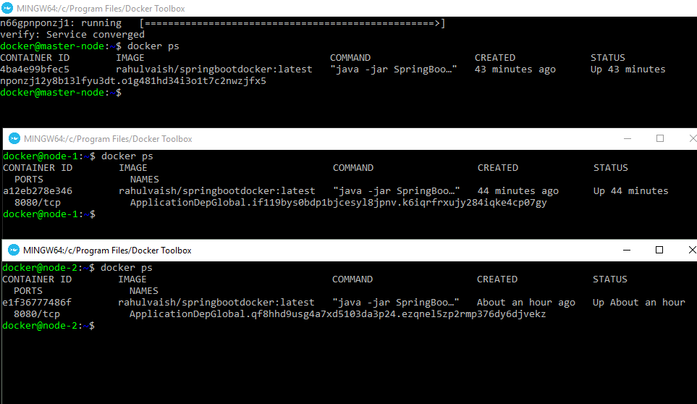
Therefore, we can see that instances of the application are running on all 3 nodes ☺
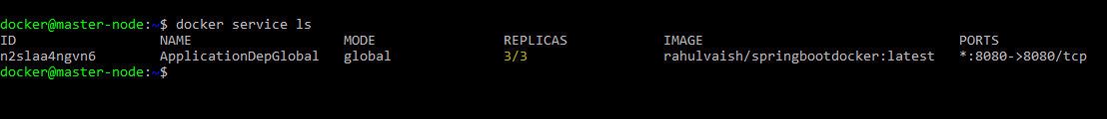
Again, we can see the number of replicas =3 . One Replica/Node.
HIGH AVALIBILITY
To test the availability, let’s shut down one node…
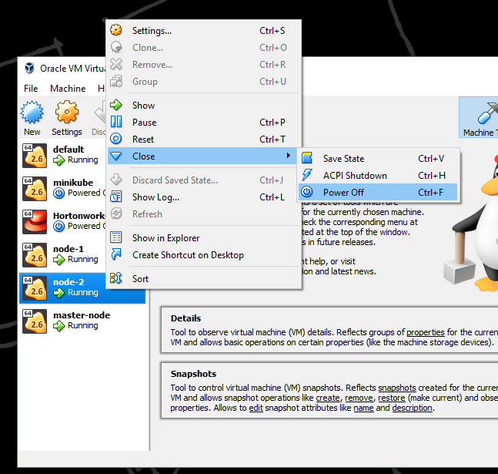
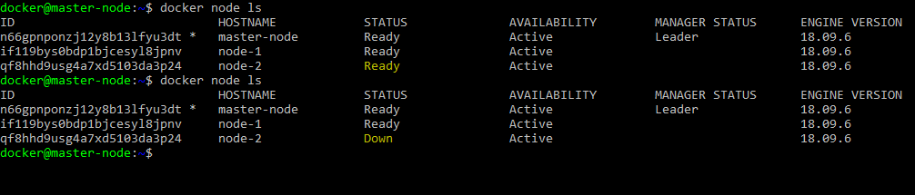
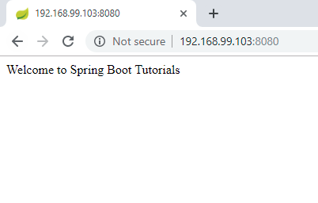
Even if one node goes down, the application is running ☺

Now, start the node (From Virtualbox)
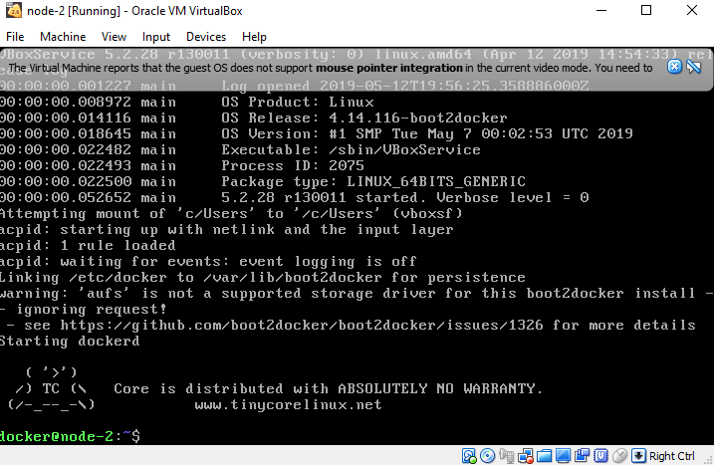
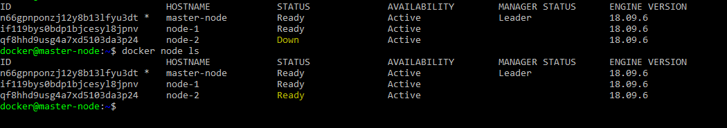
The earlier state is restored!!
Earlier we saw that we deployed the application on all three nodes, in case we want to make deployment on let say only 2 nodes, then:
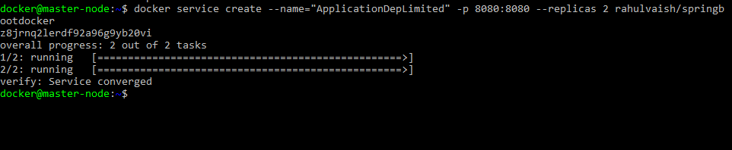
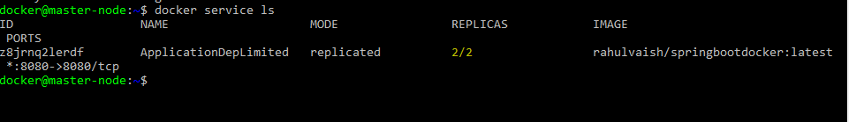
Now which are these two nodes?
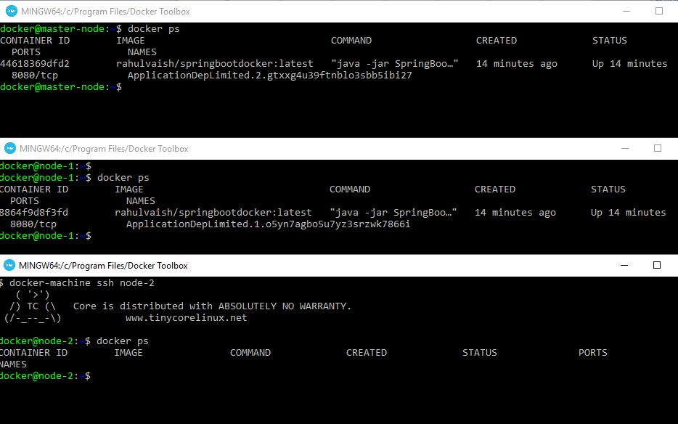
The service is UP and RUNNING on Node-1 and master.
Scaling up our application on Node-2….
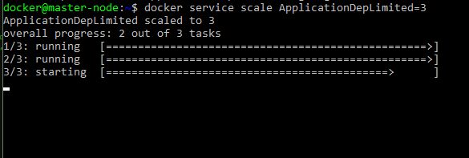
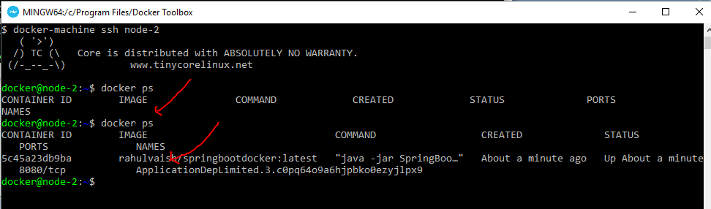
Before/After state of Node-2

Experimenting some Thoughts:
Q1. Deploy SpringBootDocker and SpringBootDocker –v2 on Docker Swarm.
The deployment of springbootdocker happened on node-1 and deployment of springbootdocker-v2 happened on node-1. Node-2 empty with no deployment made over there.
Q2. On 3 nodes (in total) if we replicate the Application on 10 nodes, what will happen?
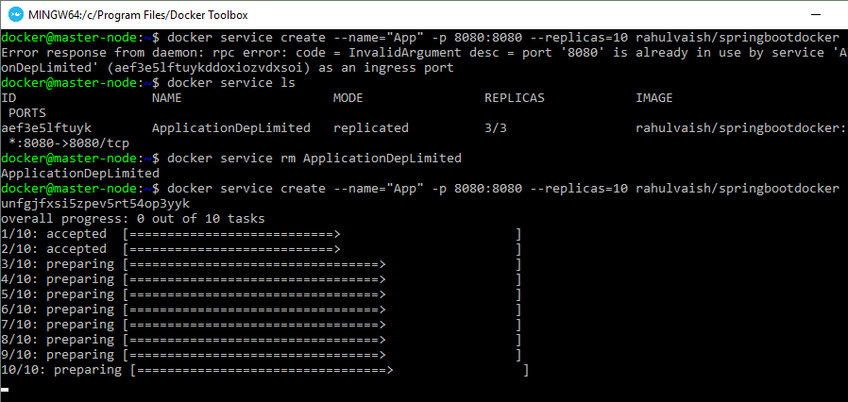
These 10 instances are divided into all 3 nodes:
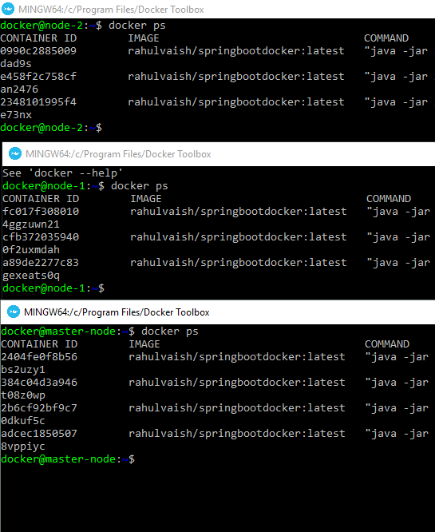
Q3. What if we switch on any node that does not exists?
Answer:
Lenovo@VAISH MINGW64 /c/Program Files/Docker Toolbox
$ docker-machine ssh node-10
Docker machine "node-10" does not exist. Use "docker-machine ls" to list machines. Use "docker-machine create" to add a new one.

Q4. How to make a node free from deployment?
Answer:
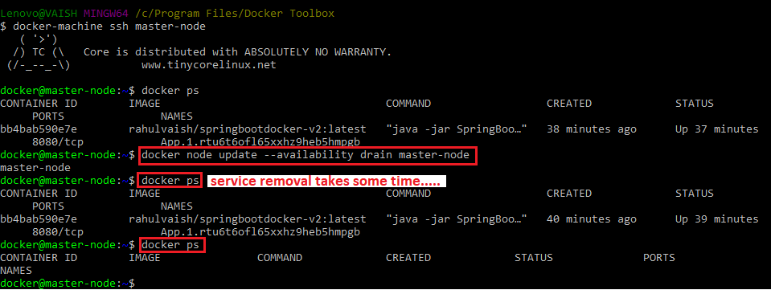
To understand - We have set the replication factor as 2, therefore when we removed the service from the master node, 2 replicas got created on Node-2, which was then empty…
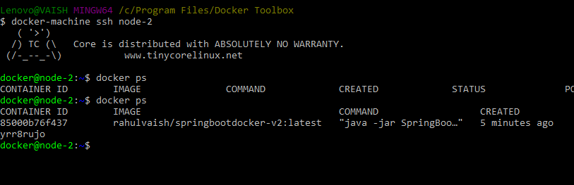
This activity also tagged that master node won’t take any deployments, therefore, on re-trying a deployment ,the deployment will goes with any other node (except master), here in our case it is node-2.
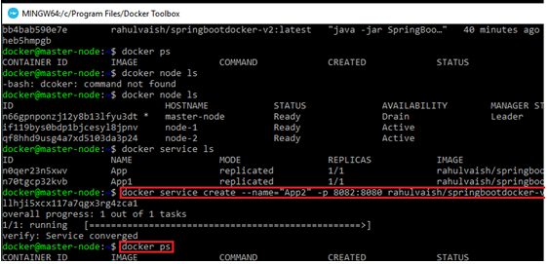
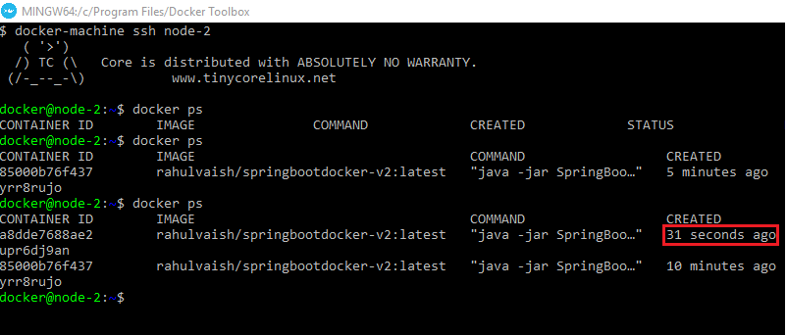
To revert the tag execute: docker node update --availability active master-node

Docker Swarm vs Kubernetes:
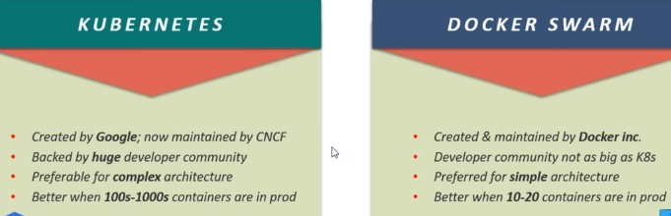
K: Setting up Kubernetes Cluster is complicated and time taking.
DS: Easy
K: GUI
DS: No GUI
K: Scalability is easy
DS: Scalability is easy and 5X Faster
K: Autoscaling
DS: Manual Scaling
K: Manual Load Balancing
DS: Auto Load Balancing

